
22-24 Carr Lane, Liverpool, L11 2YA
T: 0151 256 9800 F: 0151 296 7122

Thank you for contacting the GP surgery about arranging an assessment for ADHD.
Currently the services available to patients in Liverpool is dictated to by Cheshire and Merseyside ICB. Full details in relation to this can be found at https://www.cheshireandmerseyside.nhs.uk/your-health/adhd-services-for-adults/
Many patients may request a referral via “Right To Choose” however it is important to note that this only covers providers who have a contract with our ICB. For patients registered at Ellergreen Medical Centre this includes:
  - CWP – waiting list reopening date to be confirmed
https://www.cwp.nhs.uk/our-services/liverpool/adhd-service-liverpool
  - Quay Healthcare
https://quayhealthcare.org/adhd-services/
  - Clinical Partners
https://www.clinical-partners.co.uk/nhs-right-to-choose-assessments-and-medication/nhs-right-to-choose-adhd-assessments-for-adults/
  - The Aspen Clinic
https://theaspenclinic.co.uk/
List is subject to change but is correct as of August 2026.
There are other providers who have contracts with other ICBs in England, but who don’t hold a specific contract with Cheshire and Merseyside ICB. Whilst a patient does have the right to select one of those providers the ICB cannot guarantee the safety assurance and governance of said providers.
In the near future North Liverpool Primary Care Network will be offering ADHD assessments and this option will be offered when available.
Please note that the GP surgery is not in control of the waiting lists or prioritisation that is given on these waiting lists. These details are directly controlled by the clinics themselves. It is the responsibility of the patient to review each of the options and services provided to ensure that this is the correct choice for them.

If you are happy with the above information and wish to proceed, we now need you to complete the enclosed form. The more information that you can provide, the more likely you are to receive an appointment with an appropriate service in a reasonable time frame.

Name:
……………………………………………………………………………………………………………………………………
DOB:
……………………………………………………………………………………………………………………………………
Address:
……………………………………………………………………………………………………………………………………
……………………………………………………………………………………………………………………………………
……………………………………………………………………………………………………………………………………
……………………………………………………………………………………………………………………………………
Preferred contact telephone number:
……………………………………………………………………………………………………………………………………
Email address:
……………………………………………………………………………………………………………………………………

Service selected:
- Quay Healthcare
- Clinical Partners
- The Aspen Clinic

Now please complete the Adult ADHD Self Report Scale on the next page.

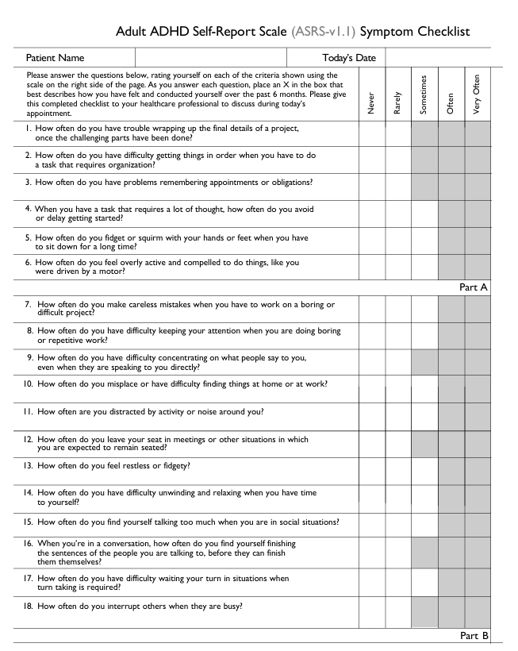

ADHD can have impacts on many aspects of life and as much information as possible in relation to this is important. Please give details of any issues you have had in the following areas that you attribute to ADHD.
Where possible please detail the duration of these issues, anything that has been tried to help so far and the outcomes of those interventions.

Relationships

Education

Employment

Risk and safety.

Self-care

Any other relevant information you wish to provide:

Thank you for taking the time to complete this form.
Please now bring your completed form to the GP surgery and hand it to reception.

Please indicate by way of a signature below that you consent to the GP surgery sharing the enclosed information with the requested provider alongside a summary of your medical records.
You also agree that Ellergreen Medical Centre will not agree to initiate or titrate any medication prescribed for ADHD. We may consider a Shared Care Agreement with the registered provider but this is dependent on a safe prescribing arrangement being agreed. Until said agreement is signed, all prescribing must be done by the ADHD clinic.
Signed:

……………………………………………………………………………………………………………………………………

Name:
……………………………………………………………………………………………………………………………………

Date:
……………………………………………………………………………………………………………………………………

